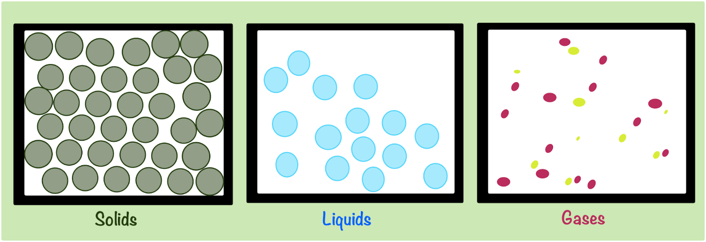

Gas

|  |  |  |  |  |  |
| --- | --- | --- | --- | --- | --- |
| Define and use the terms normal, angle of incidence and angle of reflection  Describe the formation of an optical image by a plane mirror, and give its characteristics, i.e. same size, same distance from mirror, virtual  State that for reflection, the angle of incidence is equal to the angle of reflection; recall and use this relationship  Use simple constructions, measurements and calculations for reflection by plane mirrors | Learners set up the experiment to investigate the law of reflection.   |  |  | | --- | --- | | **Resource Plus** |  | | Carry out the *Demonstrating wave phenomena* experiment referring to Teaching Pack for lesson plans and resources. | |   Learners carry out the reflection part of the teaching pack (Worksheet F).  Introduce the law of reflection. Link to the results learners found with measuring the angles of incidence and reflection for a light ray reflecting from a plane mirror.  Ask learners what they notice when they look at their reflection in a plane mirror. They can act as a mirror to a volunteer as they raise their arms up and down or move from side to side in front of them. They may highlight that the left- and right-hand sides are flipped. Identify the characteristics of an optical image formed by a plane mirror (same size, same distance from mirror as object and virtual). Learners may need an explanation of real images and virtual images. It may help to explain briefly how both are formed. This will be explained in more depth in the section on lenses.  Image characteristics:  [www.physicsclassroom.com/class/refln/Lesson-2/Image-Characteristics](https://www.physicsclassroom.com/class/refln/Lesson-2/Image-Characteristics)  Images formed by plane mirrors:  <https://opentextbc.ca/universityphysicsv3openstax/chapter/images-formed-by-plane-mirrors/>  Show learners a simple image reflected in a mirror but with small errors: the image might be upside down when it should be upright, the image might not be laterally inverted, etc. Learners identify the error in each example, using miniature whiteboards. **(F)**  Set learners qualitative questions for practice. **(F)**  Learners investigate uses of reflection: the periscope, ‘Pepper’s ghost’, etc. They could make their own simple periscope using mirrors and cardboard, or ‘Pepper’s ghost’ using clear plastic, a filament lamp, a cardboard box and spare cardboard. **(I)**  **Extended assessment:** 3.2.1.4  Learners use the law of reflection to determine the final destination of a light ray on a sheet of paper as it reflects off a variety of plane mirrors. They practise their accuracy with using a protractor and drawing ray diagrams. **(F)**  Give learners a simple image and ask them to draw how it would appear as an image in a plane mirror. **(F)**  Learners carry out an experiment to find position and characteristics of an optical image formed by a plane mirror using optical pins. Investigating the position of an image in a plane mirror:  [www.bbc.co.uk/bitesize/guides/znksd6f/revision/3](https://www.bbc.co.uk/bitesize/guides/znksd6f/revision/3) |

Solid

|  |  |  |  |  |  |
| --- | --- | --- | --- | --- | --- |
| Define and use the terms normal, angle of incidence and angle of reflection  Describe the formation of an optical image by a plane mirror, and give its characteristics, i.e. same size, same distance from mirror, virtual  State that for reflection, the angle of incidence is equal to the angle of reflection; recall and use this relationship  Use simple constructions, measurements and calculations for reflection by plane mirrors | Learners set up the experiment to investigate the law of reflection.   |  |  | | --- | --- | | **Resource Plus** |  | | Carry out the *Demonstrating wave phenomena* experiment referring to Teaching Pack for lesson plans and resources. | |   Learners carry out the reflection part of the teaching pack (Worksheet F).  Introduce the law of reflection. Link to the results learners found with measuring the angles of incidence and reflection for a light ray reflecting from a plane mirror.  Ask learners what they notice when they look at their reflection in a plane mirror. They can act as a mirror to a volunteer as they raise their arms up and down or move from side to side in front of them. They may highlight that the left- and right-hand sides are flipped. Identify the characteristics of an optical image formed by a plane mirror (same size, same distance from mirror as object and virtual). Learners may need an explanation of real images and virtual images. It may help to explain briefly how both are formed. This will be explained in more depth in the section on lenses.  Image characteristics:  [www.physicsclassroom.com/class/refln/Lesson-2/Image-Characteristics](https://www.physicsclassroom.com/class/refln/Lesson-2/Image-Characteristics)  Images formed by plane mirrors:  <https://opentextbc.ca/universityphysicsv3openstax/chapter/images-formed-by-plane-mirrors/>  Show learners a simple image reflected in a mirror but with small errors: the image might be upside down when it should be upright, the image might not be laterally inverted, etc. Learners identify the error in each example, using miniature whiteboards. **(F)**  Set learners qualitative questions for practice. **(F)**  Learners investigate uses of reflection: the periscope, ‘Pepper’s ghost’, etc. They could make their own simple periscope using mirrors and cardboard, or ‘Pepper’s ghost’ using clear plastic, a filament lamp, a cardboard box and spare cardboard. **(I)**  **Extended assessment:** 3.2.1.4  Learners use the law of reflection to determine the final destination of a light ray on a sheet of paper as it reflects off a variety of plane mirrors. They practise their accuracy with using a protractor and drawing ray diagrams. **(F)**  Give learners a simple image and ask them to draw how it would appear as an image in a plane mirror. **(F)**  Learners carry out an experiment to find position and characteristics of an optical image formed by a plane mirror using optical pins. Investigating the position of an image in a plane mirror:  [www.bbc.co.uk/bitesize/guides/znksd6f/revision/3](https://www.bbc.co.uk/bitesize/guides/znksd6f/revision/3) |

Liquid

|  |  |  |  |  |  |
| --- | --- | --- | --- | --- | --- |
| Define and use the terms normal, angle of incidence and angle of reflection  Describe the formation of an optical image by a plane mirror, and give its characteristics, i.e. same size, same distance from mirror, virtual  State that for reflection, the angle of incidence is equal to the angle of reflection; recall and use this relationship  Use simple constructions, measurements and calculations for reflection by plane mirrors | Learners set up the experiment to investigate the law of reflection.   |  |  | | --- | --- | | **Resource Plus** |  | | Carry out the *Demonstrating wave phenomena* experiment referring to Teaching Pack for lesson plans and resources. | |   Learners carry out the reflection part of the teaching pack (Worksheet F).  Introduce the law of reflection. Link to the results learners found with measuring the angles of incidence and reflection for a light ray reflecting from a plane mirror.  Ask learners what they notice when they look at their reflection in a plane mirror. They can act as a mirror to a volunteer as they raise their arms up and down or move from side to side in front of them. They may highlight that the left- and right-hand sides are flipped. Identify the characteristics of an optical image formed by a plane mirror (same size, same distance from mirror as object and virtual). Learners may need an explanation of real images and virtual images. It may help to explain briefly how both are formed. This will be explained in more depth in the section on lenses.  Image characteristics:  [www.physicsclassroom.com/class/refln/Lesson-2/Image-Characteristics](https://www.physicsclassroom.com/class/refln/Lesson-2/Image-Characteristics)  Images formed by plane mirrors:  <https://opentextbc.ca/universityphysicsv3openstax/chapter/images-formed-by-plane-mirrors/>  Show learners a simple image reflected in a mirror but with small errors: the image might be upside down when it should be upright, the image might not be laterally inverted, etc. Learners identify the error in each example, using miniature whiteboards. **(F)**  Set learners qualitative questions for practice. **(F)**  Learners investigate uses of reflection: the periscope, ‘Pepper’s ghost’, etc. They could make their own simple periscope using mirrors and cardboard, or ‘Pepper’s ghost’ using clear plastic, a filament lamp, a cardboard box and spare cardboard. **(I)**  **Extended assessment:** 3.2.1.4  Learners use the law of reflection to determine the final destination of a light ray on a sheet of paper as it reflects off a variety of plane mirrors. They practise their accuracy with using a protractor and drawing ray diagrams. **(F)**  Give learners a simple image and ask them to draw how it would appear as an image in a plane mirror. **(F)**  Learners carry out an experiment to find position and characteristics of an optical image formed by a plane mirror using optical pins. Investigating the position of an image in a plane mirror:  [www.bbc.co.uk/bitesize/guides/znksd6f/revision/3](https://www.bbc.co.uk/bitesize/guides/znksd6f/revision/3) |

Melting

Freezing

Condensation

Vapourisation

Sublimation

Deposition

Reflected ray



